

Delphi Web Studio Editor Reference
  - Windows edition
Last changed November 6 2026
Use this illustrated reference for the current editor. It covers the command menus, project files, floating properties windows, object tools, and the media library. The longer User Guide, Engineering Guide, and Runtime Flow remain useful for the rest of the application.
The screenshots use disposable example data. Start with your own saved project file or create a new local draft from the Dashboard.

Contents

Find your way around the editor 3
Open and save a project 4
Select and arrange objects 5
Browse and place media 6
Choose files for existing objects 7
Settings and keyboard shortcuts 8
What happens during a save 9

The table of contents is a Word field. In a word processor, update the table after editing or repaginating the guide.

Find your way around the editor
Open a project from the Dashboard, then use the menus above the canvas. The editor keeps common project controls visible and puts less frequent tools in menus.
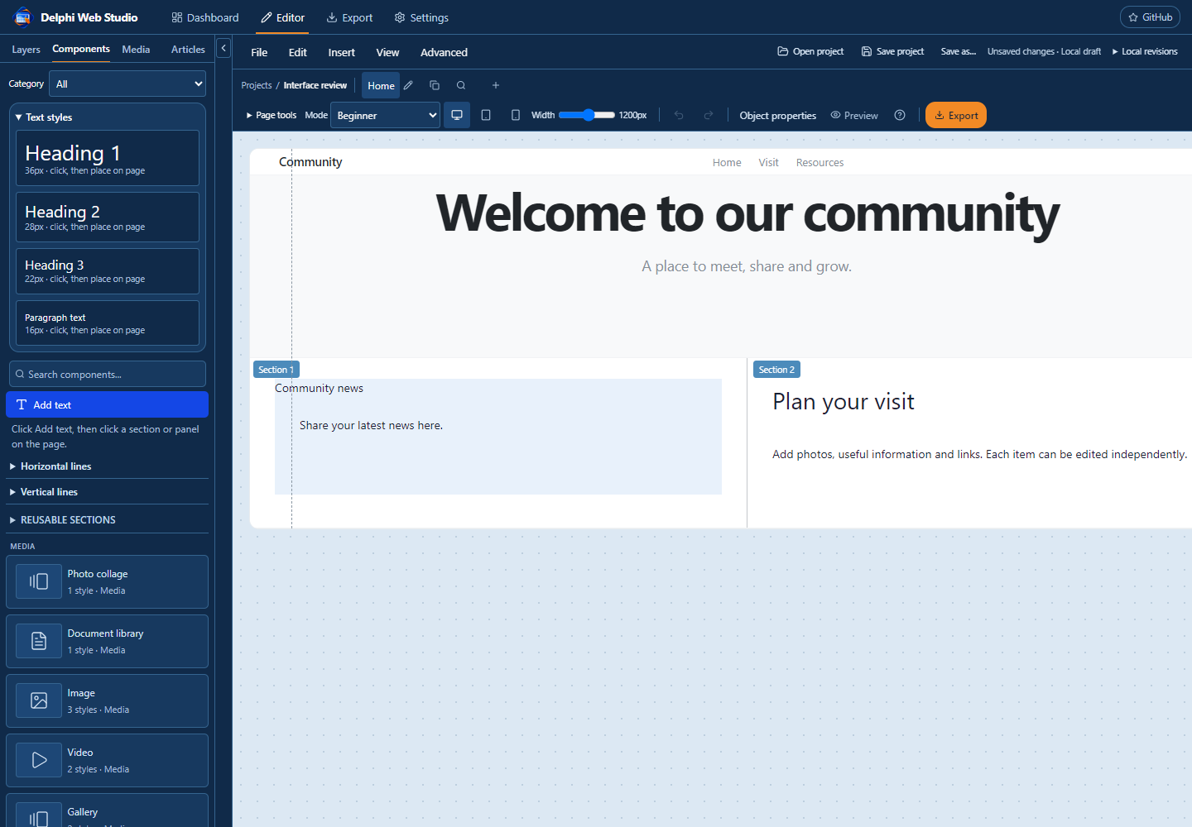
Figure 1. The editor with the Elements palette open and a sample home page.
Menu | Use it for
File | Open, Save, Save As, the Dashboard project list, and website export.
Edit | Undo or redo changes, use clipboard commands, and open Layers.
Insert | Place text, panels, and lines, or open the media library.
View | Open Elements, Layers, or Media, switch to Preview, and see shortcuts.
Advanced | Import HTML or WordPress content, inspect project JSON, or view undo history.

Open and save a project

Open a saved file or a local draft
Use File > Open project or Ctrl+O to open a project JSON or ZIP. The Dashboard cards reopen local drafts and show a small preview of the page and the last local edit time. Open the saved file when you want Save to return to that file in this desktop session.

Save and Save As
1. Use Save or Ctrl+S to update the file opened or saved in the current desktop session. Choose a destination when saving a new draft.
2. Use Save As or Ctrl+Shift+S to choose another file. A successful Save As becomes the destination for later saves in that session. Choose a different name to retain the earlier file.
3. Keep the editor open until the status reads Saved. If a project with a JSON file gains media, choose a ZIP destination so the file includes those assets.
Status | What it means
Unsaved changes | The current work differs from the last confirmed file. The local draft may have newer edits.
Working or Saving | The editor is preparing the project or Windows is completing the write.
Saved | The desktop app confirmed the file write. Hover over the status for the full path.
Save failed | The file was not confirmed. Check the native status message and retry or choose Save As.

Close the editor
Use File > Exit or the window X. A clean project closes directly. If edits are unsaved, choose Yes to save and close after success, No to leave without updating the file, or Cancel to stay in the editor. A cancelled or failed save leaves the editor open.

Select and arrange objects
Click an object to select its box. Drag the object edge or use arrow keys to move it, and use the square handles to resize. Double-click editable text to change its content. When text and a panel overlap, use Alt+Click to cycle through the objects.
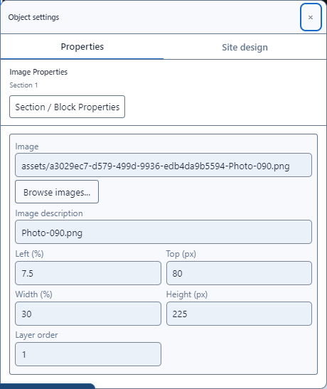
Figure 2. Image properties show only the selected image. Position and size fields sit side by side.

Use the selected object tools
- Shift+Click to select multiple objects. Alignment works for objects in the same section; Distribute needs at least three.
- Bring to front changes the layer order. Duplicate makes a copy. When a panel is duplicated, its attached items and text formatting follow it.
- Properties opens the selected object window. Move the window by its title bar, scroll the body for more controls, or close it with Escape when the window has focus.
Right-click an object to open its context menu. Use Link or Anchor when offered. Section / Block Properties switches the window to the container that holds the object.

Browse and place media
The media library displays thumbnails and file types in a full window. Import a single file or a folder of files. The grid displays up to 36 files per page; search and filters work across the full collection.
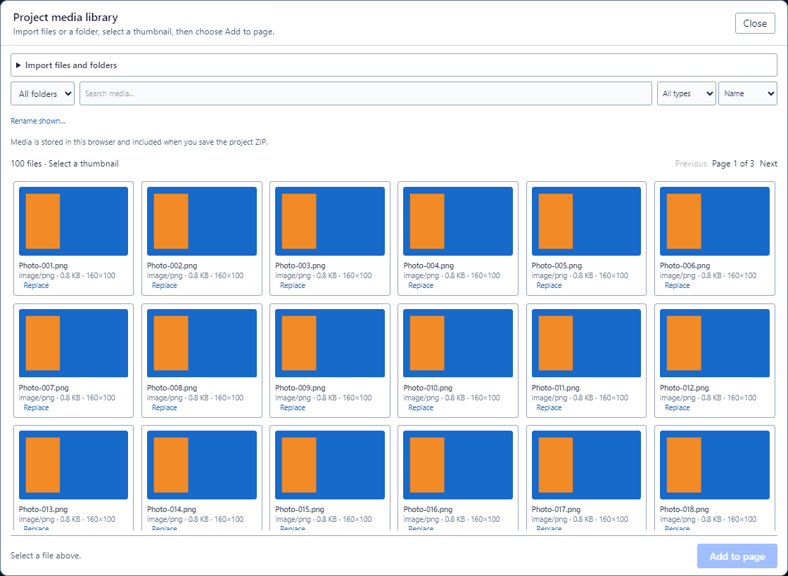
Figure 3. A 100-image test library shown in the thumbnail grid.
1. Choose View > Media library, Insert > Image, video or document, or open it from the Media tab.
2. Expand Import files and folders. Use Import media to select files, or Import folder to keep their folder paths. You can also drop files or folders into the library.
3. Select a thumbnail and choose Add to page. For an image, click the destination section or panel on the canvas. Escape cancels placement.
PDFs, local video, audio, and other supported documents are added as their corresponding page blocks. Select the new block on the canvas or in Layers to arrange it.

Choose files for existing objects
Use Browse images or Browse files in an object’s properties to select media without creating another page object. The library displays the same thumbnails and search controls.
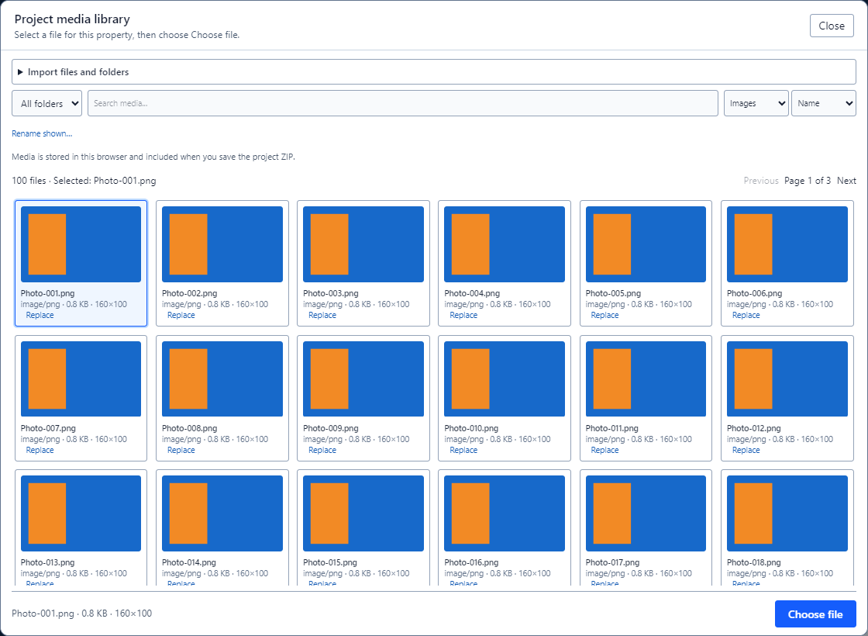
Figure 4. Choose file returns the selected asset to an existing object.

Choose an asset for a property
1. Select the image, panel, gallery item, collage, or document item. Open Properties.
2. Click its Browse button, search or filter the library, and select a file. Choose file returns the selection to the property.
3. Use Replace in the library when you intend to update an existing asset and keep its page references. Review which file is selected before replacing it.
The library stores a copy of imported bytes in the project’s local media store. Save the project ZIP to carry media to another computer. The original source files in your folders remain unchanged.

Settings and keyboard shortcuts

Where each setting belongs
Scope | Where to find it
Application | Settings > Application settings: optional Google AI and the key saved for this Windows account.
Project | Settings > Project settings and its related tabs: site identity, webmaster email, search details, domain, and analytics.
Object or section | Right-click the selected item or choose Properties on its toolbar. Changes apply to that item or its container.
Site design | Open Site design in the properties window to change website theme and typography.
Use Export to create local website files. Hosting operations have separate controls and review steps. Saving the project or exporting the website does not publish it.
Page tools contains Plan pages and Check site. Use Desktop, Tablet, or Mobile to check the layout at different widths.

Useful shortcuts
Shortcut | Action
Ctrl+O | Open project
Ctrl+S | Save to the current file
Ctrl+Shift+S | Save As
Ctrl+Z / Ctrl+Y | Undo / redo editor changes
Shift+Click / Alt+Click | Add to selection / cycle overlapping items
Arrow keys | Nudge a selected object
Esc | Close an active dialog or cancel placement
P / ? | Preview / shortcut help when focus is on the editor

What happens during a save
This page describes the save and media path for developers and support. It supplements the Engineering Guide and Runtime Flow.

Save sequence
1. ProjectFileCommands flushes inline RichText edits before it reads the current configuration and settings. The project file includes the configuration and the manifest for its referenced media.
2. The desktop bridge authorizes the save and identifies the active local project. When a file was opened through the picker, WebView2 supplies the selected file object to the host; the host associates its path with that project for this session.
3. The Delphi host chooses the current path or opens the Save As chooser. The host stages the bytes beside the destination. It validates replacement files and checks the destination version before replacing it. An unexpected external change requires confirmation.
4. On success the host sends the actual path and save token. The editor compares the saved snapshot with the current one and reports whether it is clean. If the user chose Save on exit, the host closes only after that confirmation.

Media and previews
MediaLibraryDialog presents the reusable library with folder, type, search, sort, and page controls. Imported assets remain keyed by project and asset ID. A property picker returns a file to its caller; Add to page creates a block or arms image placement on the canvas.
Dashboard thumbnails render read-only copies of the opening blocks and resolve the local media they use. Thumbnails do not run website custom scripts. They are previews; use the canvas Preview and exported files for device checks.

Validation scope
The browser smoke check imports 100 images, finds and places a file, changes an existing image, and checks panel duplication and layering. The desktop smoke checks use isolated projects to exercise the native file and media paths. These checks do not replace testing your website on its target devices.

